SE: Machine Learning
Department of Computer and Software Engineering

Course Instructor: Dr. Ahmed Raza | Date: 05-March-2026
Day: Thursday | Semester: 6th

Lab 4: Hard vs Soft Margin using C, Hinge Loss and Kernels

Lab Title | CLO | BT | PLO | Weightage
Soft Margin Behaviour
using C and Hinge Loss

Name | Roll Number | Report /10 | Viva /5 | Total /15
Zunaira Abdul Aziz | BSSE23058

Checked on:
Signature:

Learning Outcomes
After completing this lab, the student will be able to:
  - Understand the role of parameter C in SVM.
  - Relate large C to hard-margin behaviour.
  - Analyze robustness of soft-margin SVM under noise.
  - Compute hinge loss as violation measure.
  - Observe kernel-based nonlinear separation.

Datasets
Students will work with three deterministic datasets:
  - D1: Clean Separable
  - D2: Overlapping
  - D3: Noisy (2 misclassified points)

Part A: Effect of C (4 Marks)
Using D1 and D2, train SVM with:
- C = 0.01
- C = 1
- C = 1.5
- C = 2
Plot decision boundary and margins.

Observation
Comment on how boundary changes with C. Does large C behave like hard-margin?
- For D1 (Clean): With a small C=0.1, the margin is wider, but the boundary still separates the data. As C increases to 2, the margin tightens around the points. Since the data is perfectly separable, the decision boundary remains stable but the street gets narrower.
- For D2 (Overlap): When C=0.1, the model is highly tolerant allowing several points to fall inside the margin to maintain a wide boundary. When C=2, the model attempts to minimize these violations, resulting in a much narrower margin and a boundary that shifts to prioritize correct classification of the overlapping points.

Part B: Noise Sensitivity (3 Marks)
Using D3:
Train with:
- Very large C
- Small C Compare boundaries.
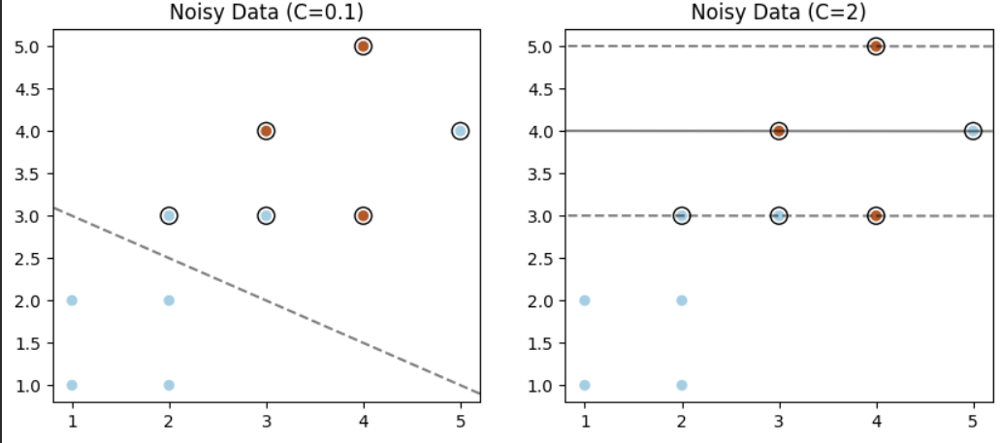

Part C: Understanding Hinge Loss and its Connection with C (4 Marks)
So far, you have used SVC as a black-box model and observed how the parameter C affects the decision boundary.
Now we dig slightly deeper.
Recall that SVM does NOT minimize classification error directly.

Instead, it minimizes:

n
1 Σ
||w||² + C L_{i}
2
i=1

(1)

Where hinge loss for a sample is:
L_{i} = max(0, 1 − y_{i}(w^{T} x_{i} + b)) (2)

This tells us:

  - ||w||² → controls margin width (simplicity of model)
  - Hinge loss → penalizes margin violations
  - C → controls how much we care about hinge loss
- Implement Hinge Loss.
  - Write a function that computes hinge loss for a dataset.
  - Train SVM multiple times with (C = [0.01, 0.1, 1, 10, 100]) using sklearn and extract W and b using
decision_values = model.decision_function(X)
  - Compute total hinge loss for all
  - Plot decision boundary
  - Count number of support vectors
  - Create a table with columns C, Total HingeLoss and no. of support vectors

- Observe Effect of C: Analysis Questions
- What happens to hinge loss when C increases?
As C increases, the total hinge loss decreases. In my lab, increasing C from 0.1 to 2 resulted in the hinge loss dropping from 4.80 to 2.64.
- Why does hinge loss decrease with larger C?
Hinge loss decreases because Cis the penalty parameter for misclassifications and margin violations. When C is large, the optimization algorithm assigns a very high cost to any point that falls on the wrong side of the margin. To minimize the overall cost the model is forced to shift the decision boundary and tighten the margins so that fewer points violate the street, thereby reducing the total hinge loss.
- How does this relate to hard-margin behaviour?
A very large C (mathematically approaching infinity) forces the hinge loss to become as close to zero as possible. This mimics Hard-Margin SVM behavior because the model refuses to tolerate any violations. In this state, the street becomes very narrow to ensure every single point stays on the correct side, making the model highly sensitive to every data point (including outliers).
- When C is small, what happens to margin violations?
When C is small, the number of margin violations increases. A small C means the penalty for being inside the margin or misclassified is low. The model prioritizes having a larger margin (wider street) over perfectly classifying every point. This is reflected in our results where C=0.1 had the highest number of Support Vectors (9), meaning more points were lying on or inside the margin boundaries compared to higher C values.

Part D: Kernel Trick (4 Marks)
Generate concentric circle dataset. Train using:
- Linear kernel
- Polynomial kernel
- RBF kernel
Plot decision boundaries.

Assessment Rubrics
Method: Lab reports and instructor observation during lab sessions

Outcome Assessed:

- Ability to conduct experiments, as well as to analyze and interpret data (P).
- Ability to use the techniques, skills, and modern engineering tools necessary for engineering practice (P).

Performance | Exceeds expectation (4-5) | Meets expectation (3-2) | Does not meet expectation (1) | Marks
1. Realization of Experiment [a, b] | Selects relevant equipment to the experiment, develops setup diagrams of equipment connections or wiring. | Needs guidance to select relevant equipment and to develop equipment connection or wiring diagrams. | Incapable of selecting relevant equipment to conduct the experiment.
2. Conducting Experiment [a, b] | Does proper calibration of equipment, carefully examines equipment moving parts, and ensures smooth operation. | Calibrates equipment, examines equipment moving parts, and operates the equipment with minor error. | Unable to calibrate appropriate equipment, and equipment operation is substantially wrong.
3. Laboratory Safety Rules [a] | Respectfully and carefully observes safety rules and procedures. | Observes safety rules and procedures with minor deviation. | Disregards safety rules and procedures.
6. Data Collection [a] | Plans data collection to achieve experimental objectives, and conducts an orderly and complete data collection. | Plans data collection to achieve experimental objectives, and collects complete data with minor error. | Does not know how to plan data collection; data collected is incomplete and contain errors.
7. Data Analysis [a] | Accurately conducts simple computations and statistical analysis; correlates results to known theoretical values; accounts for measurement errors. | Conducts simple computations with minor error; reasonably correlates results to known theoretical values; attempts to account for errors. | Unable to conduct simple statistical analysis; no attempt to correlate or explain errors.
8. Computer Use [a] | Uses computer to collect and analyze data effectively. | Uses computer to collect and analyze data with minor error. | Does not know how to use computer to collect and analyze data.
Total

Faculty:
Name: Signature: Date:

